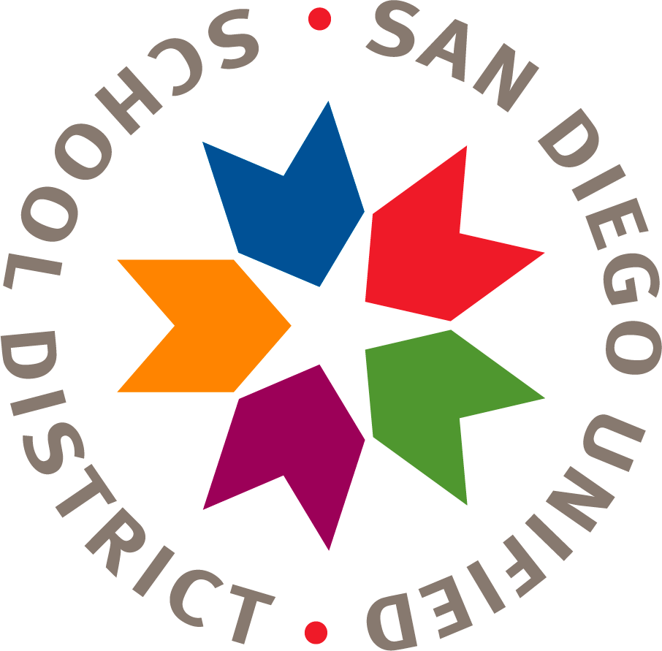
San Diego Unified School District
Financial Planning and Development
Financial Planning, Monitoring and Accountability Department

Encanto Elementary
Title 1 School Parent Compact
Year 2020-21

This School Parent Compact is in effect year 2020-21

Encanto Elementary distributes to parents and family members of Title I, Part A students, a school-parent compact (Compact). This Compact, which has been jointly developed with parents, outlines how parents, the entire school staff, and students will share the responsibility for improved student academic achievement. This Compact describes specific ways the school and families will partner to help children achieve the state’s high academic standards. This Compact addresses the following legally required items, as well as other items suggested by parents and family members of students Title I, Part A students:

Required School Parent Compact provisions

- The school’s responsibility is to provide high-quality curriculum and instruction. The parents and family members will be responsible for supporting their children’s learning (ESSA Section 1116[d][1]).
- The importance of ongoing communication between parents and family members, and teachers through, at a minimum, annual parent-teacher conferences; frequent reports on student progress; access to staff; opportunities for parents and family members to volunteer and participate in their child’s class; and opportunities to observe classroom activities (ESSA Section 1116[d][2]).
- Parent-teacher conferences in elementary schools, at least annually, during which the Compact shall be discussed as it relates to the individual child’s achievement (ESSA Section 1116 [d][2][A]).
- Frequent reports to parents and family members on their children’s progress
(ESSA Section 1116[d][2][B]).
- Reasonable access to staff, opportunities for parents and family members to volunteer and participate in their child’s class, and observation of classroom activities (ESSA Section 1116[d][2][C]).

How does the school address this?
Encanto provides Title I parents with assistance in understanding the State’s academic content standards, assessments, and how to monitor and improve the achievement of their children.
- Curriculum Night: Teachers proved an overview of grade-level standards, curriculum, and assessment
- Twice yearly parent-teacher conferences
- SSC: members review monthly data, curriculum, and assessment outcomes
- ELAC: members review data, curriculum, and assessment outcomes
- SGT: review data, curriculum, and assessment outcomes
- Coffee with the Principal
- Communication with parents regarding student achievement

Encanto engages Title I, Part A parents and family members to improve the achievement of their children in meaningful interactions with the school. This Compact supports a partnership among staff, parents and family members, and the community to improve student academic achievement. To help reach these goals, the school has established the following practices:
The school provides Title I, Part A parents and family members with assistance in understanding the state’s academic content standards, assessments, and how to monitor and improve the achievement of their children (ESSA Section 1116[e][1]) in which ways?
- Parent – Teacher Conferences twice yearly and upon request of parent or teacher
- Parent Workshops
  - Parenting Classes
  - Academic Workshops
  - Counselor Meetings and Workshops
- Community Partnerships:
  - SDSU Mental Health Clinicians
  - UCSD Wellness Center
  - SE Division Police Department
  - San Diego Foodbank: Backpack4Kids
  - Diamond Educational Excellence Partnership
    - California Reading and Literacy Project
    - Motiva Parent Classes
    - 1,000 Books by Kindergarten
    - Elementary Institute of Science
    - Words Alive
    - SD Library
    - SD Children’s Choir
  - Charger Fitness Grant

Encanto provides Title I, Part A parents and family members with assistance in understanding the state’s academic content standards, assessments, and how to monitor and improve the achievement of their children (ESSA Section 1116[e][1]) in which ways?
- Curriculum Night: Teachers provide an overview of grade-level standards, curriculum, and assessment
- SSC: members review monthly data, curriculum, and assessment outcomes
- ELAC: members review data, curriculum, and assessment outcomes
- SGT: review data, curriculum, and assessment outcomes
- Coffee with the Principal
- Parent-Teacher Conference twice yearly
- Communication between teacher, school staff and parents
Encanto provides Title I, Part A parents and family members with materials and training to help them improve the achievement of their children (ESSA Section 1116[e][2]) in which ways?
- Academic workshops
- Conferences with teacher, counselor or resource teacher upon request
- Books sent home with all students
- Shared resources through:
  - Academic websites: Achieve3000, SmartyAnts, STMath
  - School Website
  - Classroom Online Platforms: Seesaw and Google Classrooms
  - Class Dojo
  - Coffee with the Principal
  - Family Fridays

With the assistance of Title I, Part A parents and family members, the school educates staff members in the value of parent and family member contributions, and how to work with parents and family members as equal partners (ESSA Section 1116[e][3]) in which ways?
- 4 ELAC Meetings a year
  - Monthly Coffee with the Principal
  - Monthly Foundation meetings
  - Monthly SSC Meetings
  - Monthly SGT Meetings
  - Counseling Workshops
  - Counseling Center for parent and family outreach
Encanto coordinates and integrates the Title I, Part A parental involvement program with other programs, and conducts other activities, such as resource centers, to encourage and support parents and family members in more fully participating in the education of their children (ESSA Section 1116[e][4]) in which ways?
- When campus is reopened:
  - Parent Room (when campus reopens)
  - Classroom or Campus Volunteer program
  - Everyone a Reader Program
  - Monthly Family Friday
  - Wellness Center
  - Honor Roll by trimester
  - Monthly Attendance Assemblies
- Counseling Center
- Partnerships for Social Emotional and Mental Health Counseling through SAY San Diego
- Partnerships for Social Emotional and Mental Health Counseling through SDSU
- DEEP: parenting classes, reading classes, and 1,000 Books before Kindergarten
Encanto distributes information related to school and parent programs, meetings, and other activities to Title I, Part A parents and family members in a format and language that the parents and family members can understand (ESSA Section 1116[e][5]) in which ways?
- All communication provided in English and Spanish and other languages as needed
Encanto provides opportunities for the participation of all Title I, Part A parents and family members, including those with limited English proficiency, disabilities, and migratory students; and that the information and school reports are provided in a format and language that parents and family members can understand (ESSA Section 1116[f]) in which ways?
- All communication provided in English and Spanish and other languages as needed
- Communication provided in both written and spoken English and Spanish
- Interpretation provided for meetings
- Accessibility to all meeting rooms

Audra Mandler /Audra Mandler/ September 30, 2020
Authorized Official authorized signature

